Module 5: Get started with generative AI in Azure

Understand generative AI applications
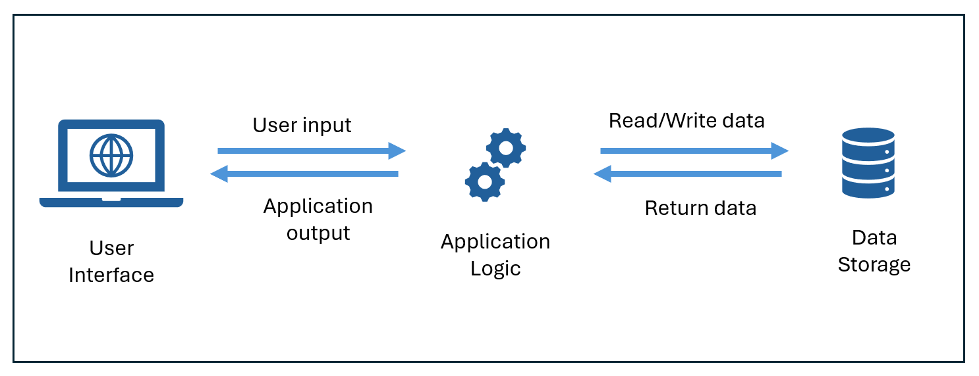

Generative AI often appears as:
- Chat-based assistants that are integrated into apps to help users find information and perform tasks efficiently (ex. Copilot)
- Act as Agents to execute tasks such as filing taxes or coordinating shipping arrangements
  - Agents are apps that can respond to user input or assess situations autonomously, and take appropriate actions.
  - Agent’s 3 Components:
    - A language model that powers reasoning and language understanding
    - Instructions that define the agent’s goals, behavior, and constraint
    - Tools, or functions, that enable the agent to complete tasks

Use a framework for understanding generative AI applications
- 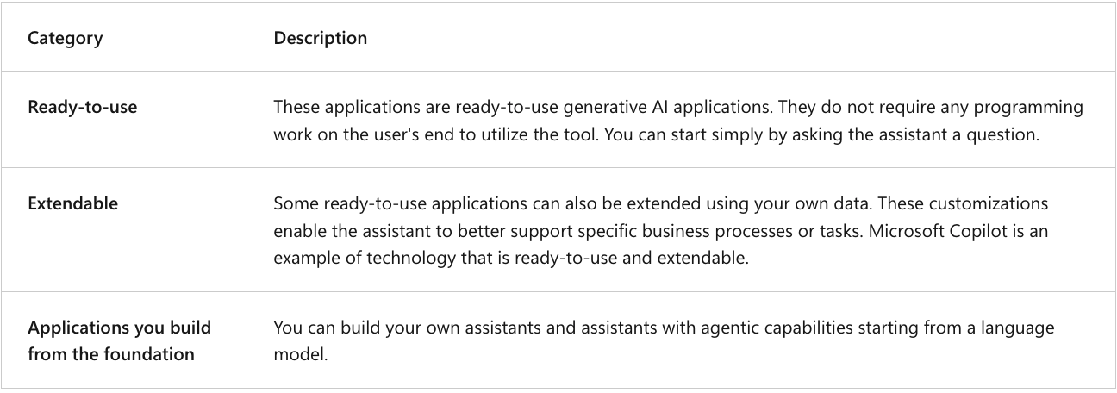

Understand tools to develop generative AI
- Azure AI Foundry, Microsoft's unified platform (PaaS) for enterprise AI operations, model builders, and application development.
  - Components:
    - 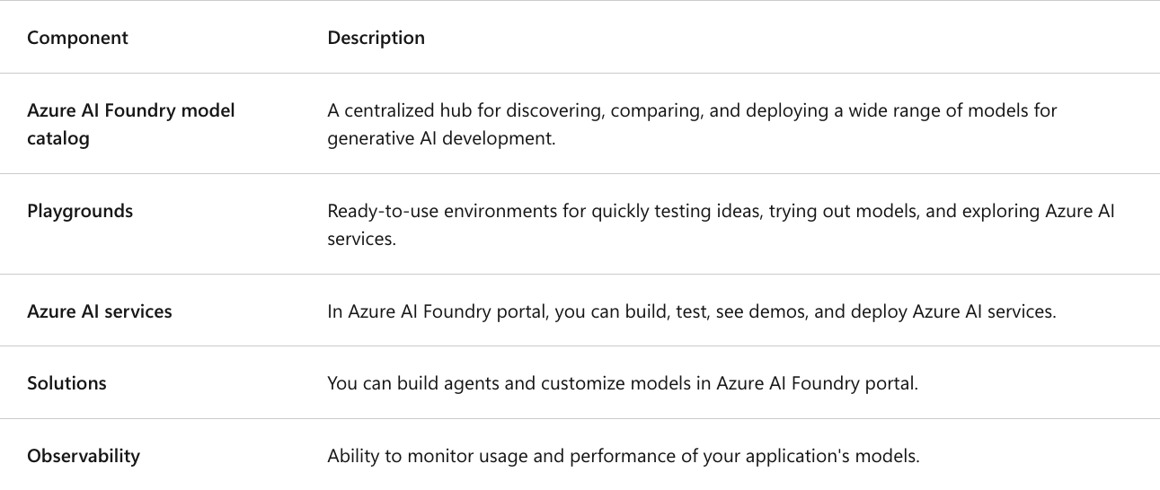

Understand Azure AI Foundry's model catalog
- Azure OpenAI in Foundry models
  - Are...Microsoft's first-party model family (foundation models are pre-trained on large texts and can be fine-tuned for specific tasks with a relatively small dataset)

Understand Azure AI Foundry capabilities
- AI Foundry UI is based around:
  - Hubs with Projects (within a hub, you can create projects)
    - Projects provide more specific access to models and agent development.

Customizing models
- 4 the main ways to customize models in Azure AI Foundry:
  - 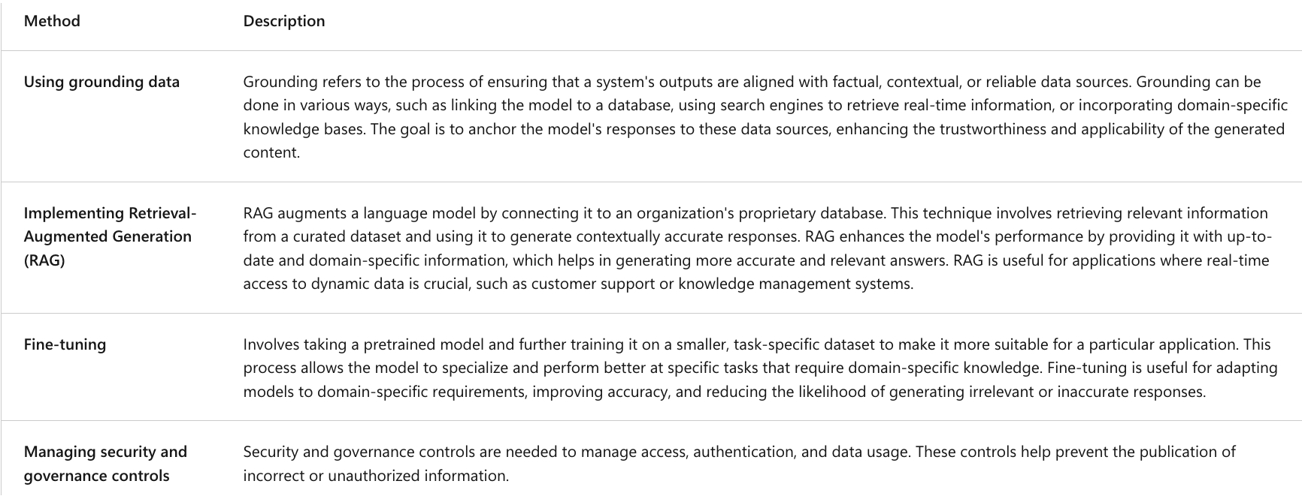

Understand observability
- 3 dimensions for evaluating and monitoring generative AI:
  - Performance and quality evaluators:
    - Assess the accuracy, groundedness, and relevance of generated content.
  - Risk and safety evaluators:
    - Assess potential risks associated with AI-generated content to safeguard against content risks (ex. evaluating an AI system's predisposition towards generating harmful or inappropriate content.
  - Custom evaluators:
    - industry-specific metrics to meet specific needs and goals.
- Some evaluators include:
  - Groundedness: measures how consistent the response is with respect to the retrieved context.
  - Relevance: measures how relevant the response is with respect to the query.
  - Fluency: measures natural language quality and readability.
  - Coherence: measures logical consistency and flow of responses.
  - Content safety: comprehensive assessment of various safety concerns

